The Convener
IEC-NRI Medical College &General Hospital,
Chinakakani, Guntur (Dist.), AP.

Project Title :

Department :
Place of Study :
Purpose of the Study :
Principal Investigator :
Name :
Affiliation :
Email :
Co-Investigators/ Guide :
- Name :
Affiliation :

- Name :
Affiliation :
Duration of study :
Sponsors (if any) :
Approval from any other Ethics / Regulatory Committee (if required):

I shall follow the Good clinical practice guidelines and approved protocol in conducting the research project. Further I/we declare that any sort of inclusion of text or pictorial material which amounts to Plagiarism will be avoided.

Signature of HOD Signature of the Investigator(s)

Signature of the Guide

SYNOPSIS
Title :
Principal Investigator :
Department & Institution :

Introduction:

Aims & Objectives:

Methodology:

Study design:

Study setting:

Study population:

Inclusion criteria:

Exclusion criteria:

Method of Collection of Data
Statistical Analysis:

References:

STUDY FLOW CHART

Title :
Principal Investigator :

Department & Institution :

Recruitment of the subject & Enrollment

Selection of patients as per the inclusion-exclusion criteria

Making study groups

Study Procedures

Data collection

Statistical analysis

Conclusion

ID No. ______
Mobile No: Mobile No:

INFORMED CONSENT FORM (ICF)
Mobile No:
Title:
Principal Investigator:
Department & Institution:

I……………………………………………..…aged about ………………..years, a resident of…………………………………………. village of ………………. District, have been detailed about the procedure. I know the benefit and risk of the said research project. I on my own will, agreed to participate in this study. I understand that my identity will not be disclosed and I can withdraw from the study at any point of the time without assigning any reason. My withdrawal from the study will not affect my ongoing treatment.
------------------------------------ ----------------------------------------
Signature of the Witness if necessary Signature of the Participant
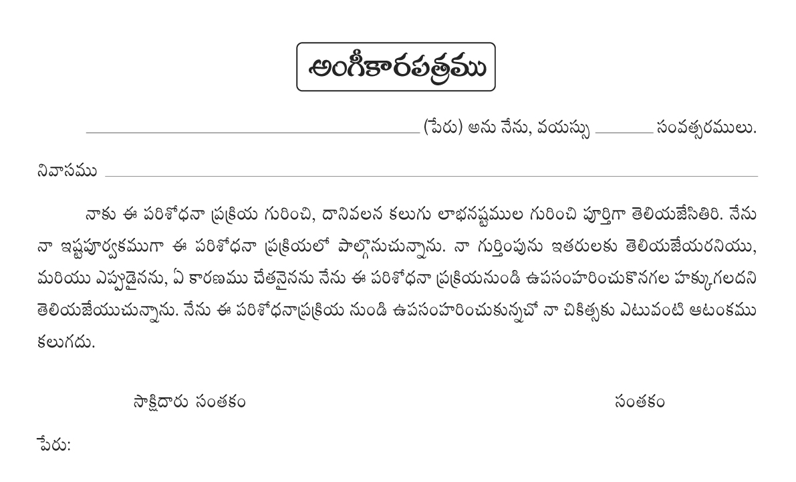

CASE RECORD FORM (CRF)
ID NO:

Title :
Principal investigator :
Department& Institution :

Signature of the person collecting the data

